Chapter 19, Problem 1.

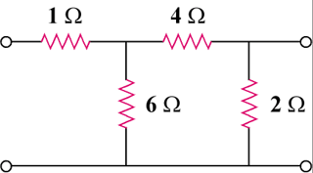
Obtain the z parameters for the network in Fig. 19.65.

8 Ω

4 Ω

12 Ω

2 Ω

8 Ω

2 Ω


4 Ω

12 Ω

Figure 19.65
For Prob. 19.1.

